**The Greater Haywards Heath**

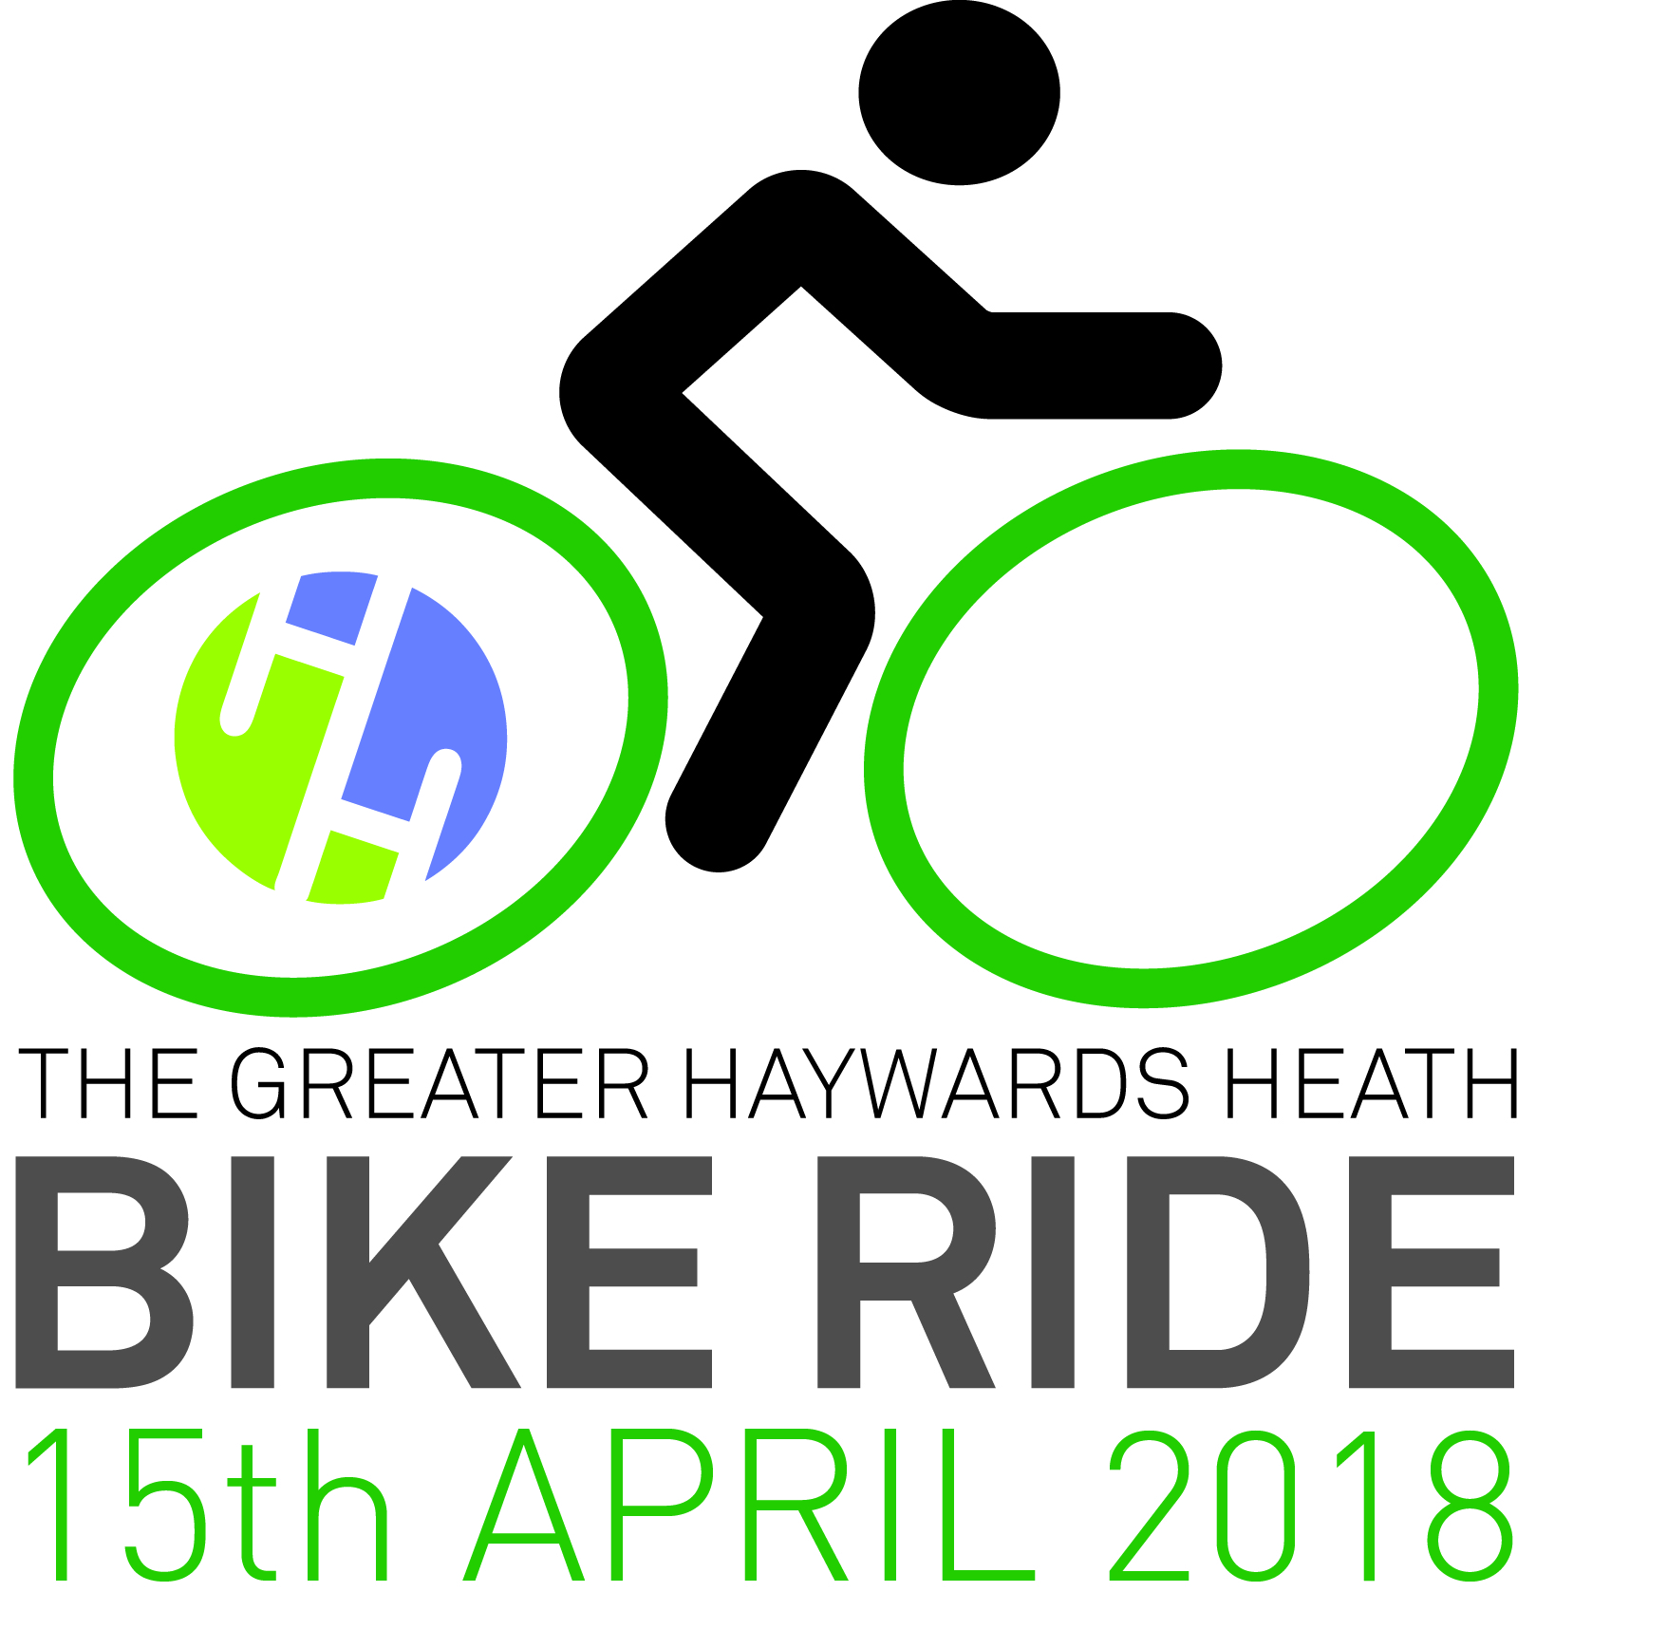

**BIKE RIDE ENTRY FORM**

**Enter on line via our website www.hhbikeride.co.uk**

**Get the Bike Ride T-Shirt for just £2.99!**

|  |  |  |  |
| --- | --- | --- | --- |
| **Title: Mr/Mrs/Ms** |  | **Date of Birth:** |  |
| **First Name:** |  | **Your Age:**  **on the day of the event** |  |
| **Surname:** |  | **All riders under 16 must be accompanied by an adult** | **All riders under 18 must fill out parental Consent Form** |
| **Address:** |  |  |  |
| **Home Tel. Number:** |  | **Mobile Number:** |  |
| **Email address:** |  | **Emergency**  **Phone No.+ Contact** |  |
| **Medical conditions**  **(if applicable)** |  | **BUY OUR BIKE RIDE POLO SHIRT**  **FOR JUST £2.99** | **Medium Size ...........**  **Large Size ...........**  **Xtra Large Size ...........** |

**Event Cost until 20.03.2018**

* **Wiggins Way** (73.4 miles)

@ £20 per rider

* **The Highwayman,** (48.2 miles), **The Cavalier** (20.8 miles) **The Sergison** (12.7 miles)

@ £10.00 per rider (£25 for a family with two adults + two children under 16)

**Event Cost from 21.03.2018 and On the Day**

*  **Wiggins Way** (73.4 miles)

@ £30 per rider

* **The Highwayman,** (48.2 miles), **The Cavalier** (20.8 miles) **The Sergison** (12.7 miles)

@ £15.00 per rider (£30.00 for a family with two adults + two children under 16)

**Charity Teams (six riders +) can ride for discounted rate of £8.00 (£12 from 21.03.2018 and On the Day)**

**Postal entries close 6th April 2018 & online entries on Friday, 13th April at midnight.**

**Book and pay online at** [**www.hhbikeride.co.uk**](http://www.hhbikeride.co.uk) **OR, please make cheques to Haywards Heath Town Team CIC and post to:**

**Town Clerk, HHTC, 40 Boltro Road, Haywards Heath RH16 1BA**

**OR, call in to Haywards Heath Town Hall (Telephone: 01444 455694)**

I agree to wear a cycle safety helmet, and further understand that I will not be permitted to participate in the event if I do not wear appropriate protective helmet. I will also abide by the British Cycling Regulations for non-competitive cycling events and agree that I participate in this event entirely at my own risk, that I must rely on my own ability in dealing with all hazards, and that I must ride in a manner which is safe to myself and others. I am aware that when riding on a public highway the function of marshals is only to indicate direction and that I must decide whether the movement is safe. I agree that no liability whatsoever shall attach to the promoter, promoting club /Organisation, event sponsor, British Cycling or any event official or member of British Cycling or member of the promoting club / organisation in respect of any injury, loss or damage suffered by me in or by reason of the event however caused. I will participate in cycling events in a loyal or sporting manner. I will submit to disciplinary measures taken against me and will take any appeals and litigation to the authorities provided for in the Regulations. Subject to that reservation, I shall submit to any dispute that may arise exclusively to the courts. I have read and agree to abide by the above declarations. Any dispute will be governed by English Law.

**WE TAKE SAFETY SERIOUSLY. NO HELMET, NO RIDE!**

**Signed: ............................................................. .......................Date:..............................................**

